
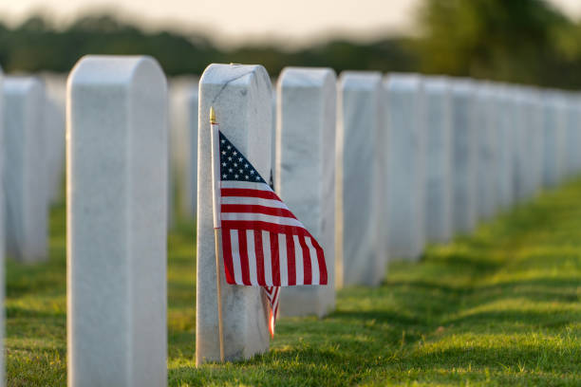
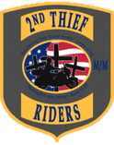
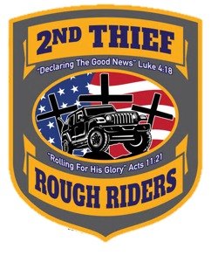
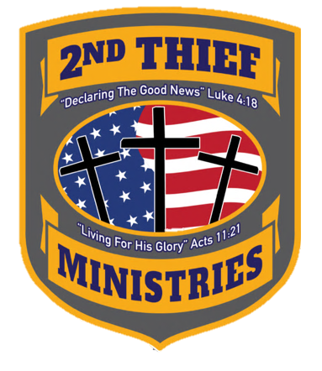
MEMORIAL DAY
Biker Blessing, Concert, and Memorial Ride
Saturday, 23 MAY 2026
Registration begins 0930
Patriots Landing
330 Elbeck Lane
Williamstowns, Kentucky 41097

2nd Thief Ministries with Patriots Landing present
Covenant Band
As the guest band for the Biker Blessing and Memorial Ride.


Whether you ride a motorcycle, drive a jeep, or travel by some other means of transportation, we hope you choose to come honor our fallen heroes with us this Memorial Day weekend.

Event Times:
Registration- 0930
Biker Blessing- 1015

Food/Meal- 1100
Route & Safety Brief- 1200

Kick Stands Up (KSU)- 1220
Memorial Stop- 1330
Return- 1430

Points of Contact for more
Information:
2nd Thief Ministries:
John “Happy” Labriola- (804)896-6560 or jlabster@yahoo.com
Patriots Landing:
Joe Montgomery (859)903-7434 or joepatriotsland@gmail.com

